St Catherine’s United Football Club  Player of the Week 2018  Award - 2017 |  |  |  |  |  | St Catherine’s United Football Club  Player of the Week 2018  Award - 2017
Congratulations to  Player Name Here  You have been awarded the Coach’s Player of the Week. Well done! | 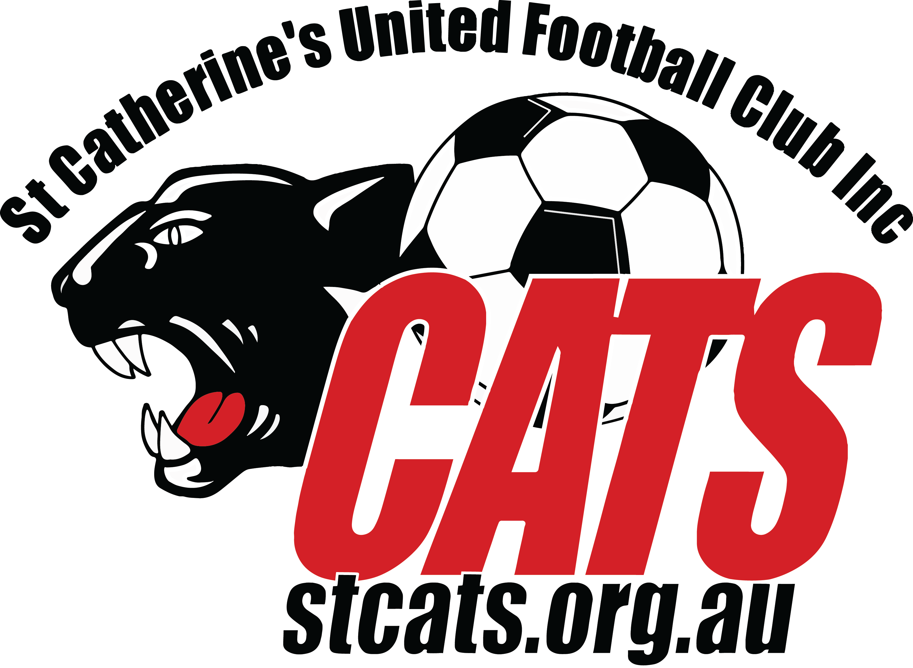 |  |  |  |  | Congratulations to  Player Name Here  You have been awarded the Coach’s Player of the Week. Well done!
 | Team Name Here |  |  |  |  |  | Team Name Here
 |  | Coach |  | Manager |  |  |  | Coach |  | Manager

St Catherine’s United Football Club  Player of the Week 2018  Award - 2017 |  |  |  |  |  | St Catherine’s United Football Club  Player of the Week 2018  Award - 2017
Congratulations to  Player Name Here  You have been awarded the Coach’s Player of the Week. Well done! |  |  |  |  |  | Congratulations to  Player Name Here  You have been awarded the Coach’s Player of the Week. Well done!
 | Team Name Here |  |  |  |  |  | Team Name Here
 |  | Coach |  | Manager |  |  |  | Coach |  | Manager

St Catherine’s United Football Club  Trainer of the Week 2018  Award - 2017 |  |  |  |  |  | St Catherine’s United Football Club  Trainer of the Week 2018  Award - 2017
Congratulations to  Player Name Here  You have been awarded the Coach’s Trainer of the Week. Well done! |  |  |  |  |  | Congratulations to  Player Name Here  You have been awarded the Coach’s Trainer of the Week. Well done!
 | Team Name Here |  |  |  |  |  | Team Name Here
 |  | Coach |  | Manager |  |  |  | Coach |  | Manager

St Catherine’s United Football Club  Trainer of the Week 2018  Award - 2017 |  |  |  |  |  | St Catherine’s United Football Club  Trainer of the Week 2018  Award - 2017
Congratulations to  Player Name Here  You have been awarded the Coach’s Trainer of the Week. Well done! |  |  |  |  |  | Congratulations to  Player Name Here  You have been awarded the Coach’s Trainer of the Week. Well done!
 | Team Name Here |  |  |  |  |  | Team Name Here
 |  | Coach |  | Manager |  |  |  | Coach |  | Manager

